C219 Front-end Web Development

**Lesson 2**

**Problem** Statement

**Little Toy Kingdom** has engaged you to design their website. They have proposed a list of some web pages required for their website:

* Home
* Shop
  + Babies
  + Boys
  + Girls
* Our Story

They require your advice on what other pages are needed for their website. You are to produce a visual sitemap for them with a complete list of web pages.

Little Toy Kingdom also wants to see some preliminary designs of a few of the web pages to get a feel of how they would look like. You are to design high-fidelity wireframes for the home page, and two other pages.

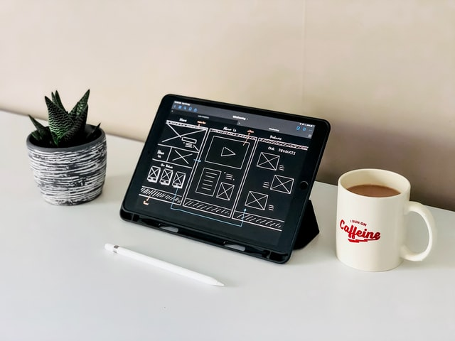

**Instructions:**

* Your visual sitemap can be done using any software you prefer
* Your wireframe page dimensions must be 1920 wide. Height can be any value depending on your page content.
* Interactions must be included in all pages
* Save your file in XD format for submission
* Share your Adobe XD link in your Reflection Journal